PART B
(PART B: TO BE COMPLETED BY STUDENTS)
(Students must submit the soft copy as per the following segments within two hours of the practicals. The soft copy must be uploaded on Blackboard LMS or emailed to the concerned Lab in charge Faculties at the end of practical; in case Blackboard is not accessible)
Roll No B032 | Name Naman Garg
Class: Btech CS B | Batch B2
Date of Experiment 3-7-2020 | Date of Submission 3-7-2020
Grade

B.1 Work done by student

(Paste your gather information and the comparison table)

- Examine the Workspace:
Type the following command into the R command panel, and hit [ENTER]
ls()
You should see the following:
character(0)
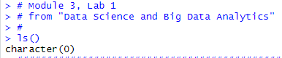

Note: R is telling you that you have nothing in your workspace.

- Getting Familiar with R
1. Click each tab in each panel. What happens?
2. Type the following commands into the R command panel

help()
help.start()
demo()
demo(graphics)

Note: Hit esc to exit out of the demo

- Working with R:

Load the .txt files you created in the first lab. Load the first file, lab1_01.txt
- Set the working directory to LAB01 where we have stored the data. On the console window type:
setwd("~/LAB01")

- Select the line and press <ctl>Enter:
lab1 <- read.table(“lab1_01.txt”, sep = “|”, header=TRUE)

- If correct, R will simply return you to the command prompt (“> “).

- Now load the second .txt file, lab1_02.txt, by modifying the command (using the line of code in the RStudio command panel) you just entered.
(Use the up/down, left/right arrow buttons to move from and within lines; change each occurrence of “lab1” to “lab2”.)
The command should read:
lab2 <- read.table(“lab1_02.txt”, sep = “|”, header=TRUE)

- When you have completed the edits, make sure that your cursor is within the line, press Enter.
Note: R supports copy and paste, as well as up and down arrows for moving to previous commands, left and right arrows to move within/between lines and home/end to move to the beginning or end of a line.
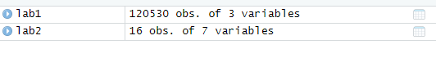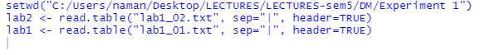
- Verify the Contents of the Tables:
It is always a good idea to look at the data to make sure that everything works. You can use the head() command to print out the first 6 lines of a table or the, tail() command to print out the last 6 lines of the table.
- Select and run the command:
head(lab1,n=10)
Record the value of the 10th line here:
10 1791 271800 8

- Now do the same for the lab2 table, but use the tail(lab2, n=10)
command instead.
- Record the value of the 1st line here:

- Manipulating Data Tables (data frames) in R:

Examine the contents of the table in more detail.
- Execute the following command:
summary(lab1)
Ignore the values for the hinc and rooms columns for now. The serialnoid field represents a unique identifier (it’s the household identifier) from the Postgres database. You no longer need it and it will interfere with some of the procedures you want to run against this data set, so create a copy of the lab1 table without that column.
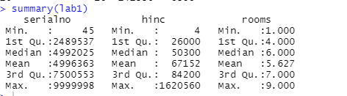

- Select and run:
nlab1 <- lab1[,2:3]
This uses a feature of R that allows us to refer to rows and columns in a dataframe as if they were entries in a matrix. A blank entry in a row or column position means “use all available.” This statement says: use all the rows in the table, but only use columns 2 and 3

You could have used the following for the same effect (Note that the following code is not part of the script you can see in the source file Module3lab1.R):
hinc <- lab1$hinc
rooms <- lab1$rooms
nlab11 <- data.frame(hinc, rooms)

You’re taking advantage of R behavior that names the columns after the name of the variable. You could have used the following for the same effect:
nlab11 <- data.frame(lab1$hinc, lab1$rooms)
names(nlab11) = c(“hinc”, “rooms”)
- The dim(<table>) has the nice property of telling us how many rows exist in the table. Execute the following commands:
dim(nlab1)
typeof(nlab1)
class(nlab1)
Each of these commands tells us something about this particular object. You may not use these often, but they can be useful when R complains that it doesn’t like something about the object that you just used. 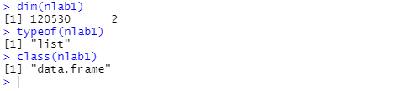

- Continue to Investigate Your Data:

- Select and execute the following commands:
summary(nlab1)
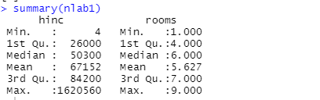
cor(nlab1)
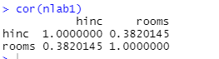
The summary function for data frames prints out summary statistics.
- Compare the median and the mean. What does it mean if the mean is less than the median?
  - The data is left or low skewed.
  - It means that average of the data lies in the lower half of the range of data

- How about the mean greater than the median?
  - The data is right or high skewed.
  - It means that average of the data lies in the upper half of the range of data
- Does the min and max value for the quartiles make sense to you?
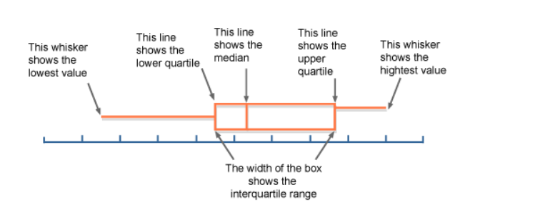
Using this diagram we can see the min and max values of each quartiles will be
1st quart- min=0th percentile max=25th percentile
2st quart- min=25th percentile max=50th percentile
3st quart- min=50th percentile max=75th percentile
4th quart- min=75th percentile max=100th percentile
Therefore for eg. The third quartile (also called the upper quartile) is where 25% of the data lies above this point and 75% below it.
Here again you have a chance to do further cleaning of your data sets, but postpone this until you’ve finished the next few lessons.
- How do the values returned by the cor() function differ from the results obtained in lab 1?
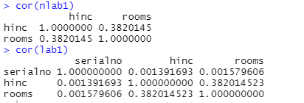
Since the nlab1 is missing one row of data the correlation is missing one row and one column
- Save the Data Sets:

- Execute the following commands:
rm(lab1)
lab1 <- nlab1
save(lab1, lab2, file = “Labs.Rdata”)
rm(lab1, lab2)
ls() # make sure they‟re not in the workspace
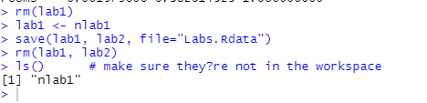
- Examine Your Data:

- Experiment with some of the examples used in the lecture portion of this lesson. Using the same selection techniques that you used earlier, run each line in the file.
  - Some commands don’t print their results. If this is the case, type in the value of the variable you created in the command window. If the variable was named “x”, you can type “x”. You can also type “print(x)” which will do the same thing.
- Experiment with R functions that identify the class and data type of a particular variable, type: typeof(x), class(x), attributes(x), names(x), dim(x)

  - Typeof
  - Attributes,
  - names,
  - Dim
- Type these values into the RStudio command panel. ____________________

- Typing all these commands for each variable is tedious. Alternatively, we will write a function tellme that takes a variable as an argument and performs typeof, class, names and str on that variable.

Select and run the lines beginning with “tellme <- function(x){extending through the right curly brace.
- Now execute the following command
tellme
You should see the definition of the function that you just entered! This is because R doesn’t interpret a plain tellme as a function, but rather as an object to be printed out. The default print function for a function is to print its definition. You can try this with any other R function. Type mean and inspect the results.
- Try tellme() with a series of variables.
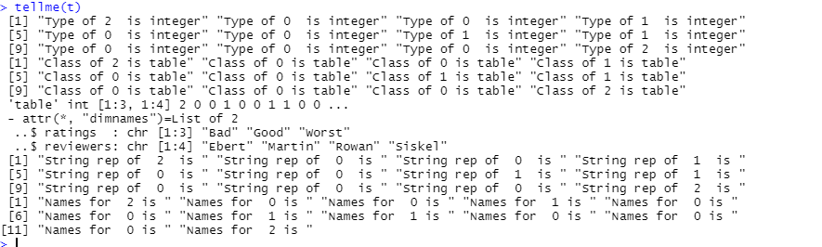
- Which commands actually list something?
All commands except for names are listing data
- How might you get the other commands to list their return value?
[Hint: try print()]
print(names(t))

EXTRA QUESTIONS::

Q.1 Define matrix of size(5,4) and store it in mat1

mat1 = matrix(, nrow = 5, ncol = 4)
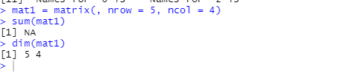

Q.2 How vector and list are define in R? Give example of each. Can you convert list to array? how?

X = list(FALSE, 1:4,5,3)

as.vector(unlist(X))

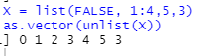

can Vector contain elements of different data type?
Ans: NO
VERIFICATION::
Code:
x = c(1, 2, 3,4 ,5)
print(x)
x[3]='naman'
print(x)
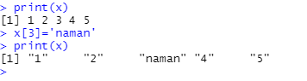
Therefore we can see that when 1 element is converted to character then all the elements are converted to retain homogeneity
B.2 Conclusion
LEARNT DIFFERENT R FUNCTIONS.
Understood how to set up the working directory. Understood how to read datasets and text files Understood how to install and use packages Understood different datatypes and inbuilt functions in R

